**Data Source**

In order to meet above expectation, we need a data source that gives information on numbers Covid-19 positive cases reported in each of the sates of India. this data was downloaded from on 27th of July.

1. Covid-19 cases reported on daily basis from 1 Apr 2020 till end 27 Jul 2020 downloaded from Kaggle.

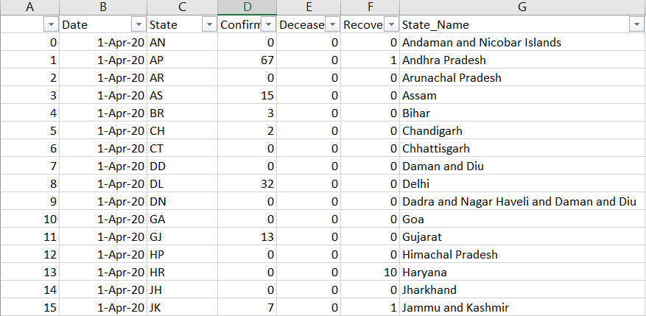

*Number of recovered cases are not considered as these were very small compared to number of cases reported

1. Per capita income of each state is extracted form Wikipedia

<https://en.wikipedia.org/wiki/List_of_Indian_states_and_union_territories_by_GDP_per_capita>

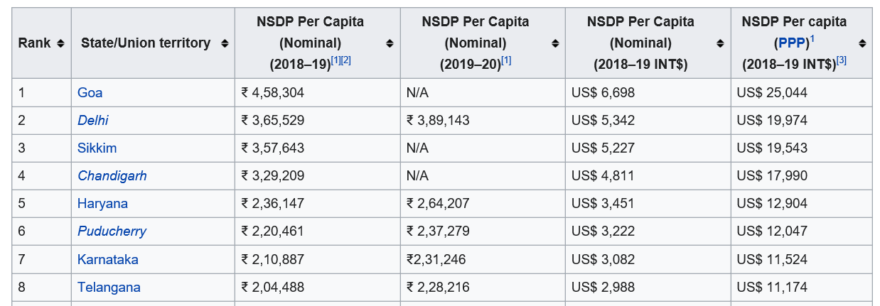

*Per capita income in FY19-20 are considered to give an idea on kind of living conditions that can be expected in a city/town within the given state.

1. Indian cities geo location information downloaded from Kaggle

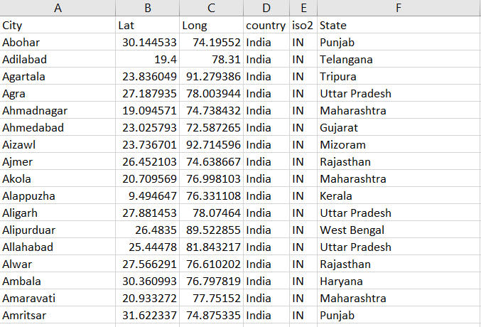

As per the requirement, first States with more than 50k Covid-19 positive cases needs to be excluded. The cases reported are grouped by state.

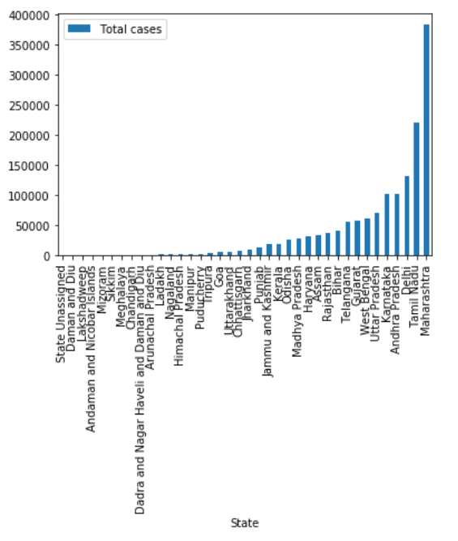

**Top 10 states with highest number of Covid-19 cases are identified**

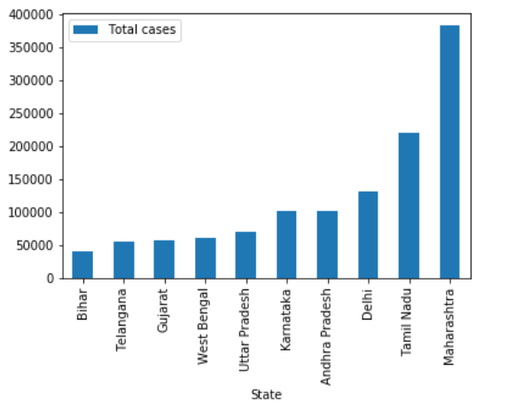

The states with more than 50k cases are excluded from the data frame. Then all the 3 data sources combined to get a single view of city, latitude, longitude, state, number of cases reported, per capita income etc.

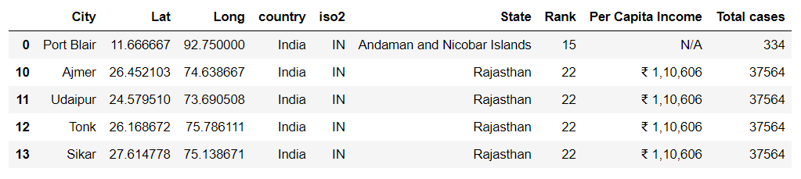

Use Foursquare API to get facilities/venue details of each Neighborhood/City

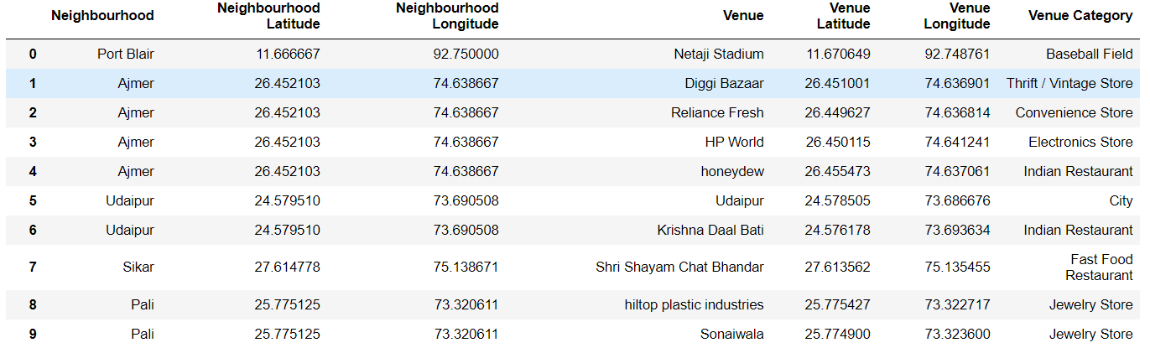

Get the data to the right format so it becomes easy to analyze.

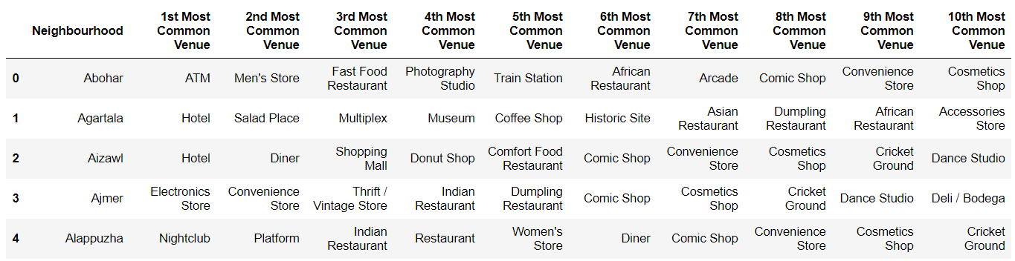

Cluster the data and plot the map.

The map shows cities/towns that are safe to relocate. However the a citizen can select a cluster (our of 5 denoted by 5 different color on the chart) based in his/her preferences/interests.

